Random Whole Numbers

Look at this code:
import random
random.seed(7)
roll = random.randint(1, 6)
print("Dice roll:", roll)

What do you think this code will display?
Click or tap here to enter text.

Run the code. Compare the result with your prediction:
Click or tap here to enter text.

Let’s investigate! Answer the questions below:
- Why can random.randint(1, 6) produce both 1 and 6?
Click or tap here to enter text.

- What value is stored in roll when the starter program uses seed 7, and why does the same value appear on another run?
Click or tap here to enter text.

- Why is the random result stored in roll before it is printed instead of calling randint() again in print()?
Click or tap here to enter text.

Click or tap here to enter text.

Random Whole Numbers

Look at this code:
import random
random.seed(7)
roll = random.randint(1, 6)
print("Dice roll:", roll)

Use the code above to help you. After completing each challenge below, run your program to test that it works correctly. Save each completed challenge program in a new file.

Programming Challenges

Challenge 1
Turn the die into a twelve-sided die. Keep seed 7; the displayed result must stay between 1 and 12 inclusive.
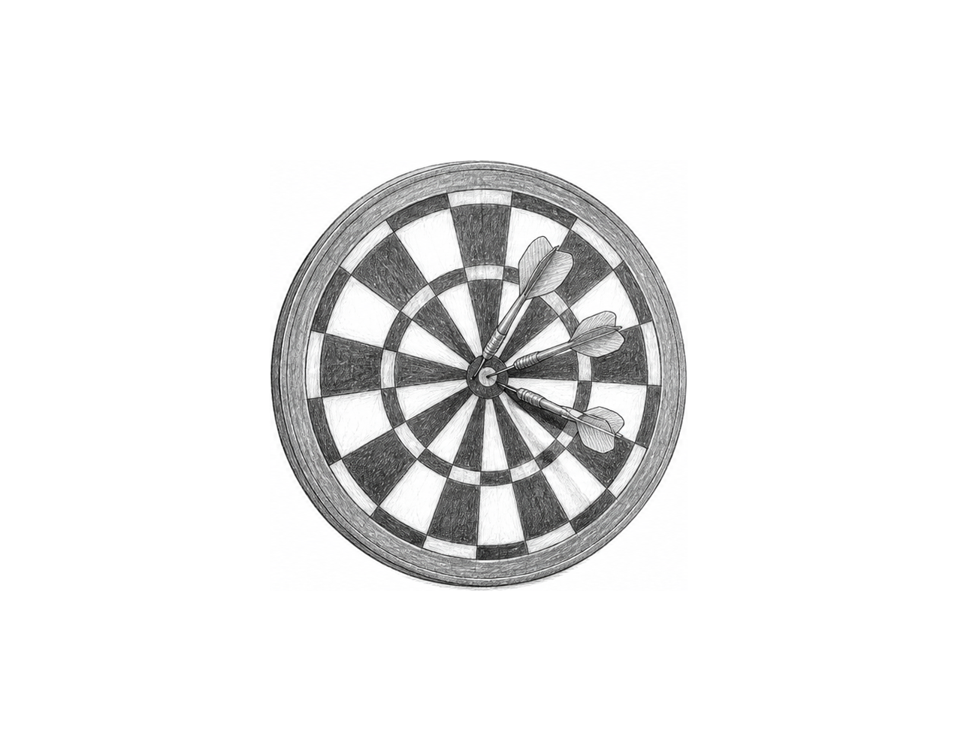

Challenge 2
Generate two six-sided rolls and display their total. With seed 7, the two stored rolls must be generated on separate lines.

Challenge 3
Create a random practice target. Ask for a minimum and maximum whole number, generate one target inside those inclusive bounds, and display it with a label. Test bounds 4 and 4; the target must be 4.

Random Whole Numbers

Fix the code!

This code has errors! Look closely at the code to find the problems:

import random
random.seed(7)
roll = random.randit(1 6)
print("Dice roll:", role)

Rewrite the whole program in the box below with fixes to the errors.
Click or tap here to enter text.

After you are confident that you fixed all the errors, copy the code from the box and run it.

Did it work correctly on your first try? Did you find all the errors?
Click or tap here to enter text.

